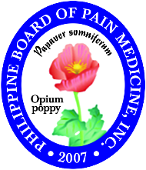
Philippine Board of Pain Medicine, Inc.

Certifying board for the practice of Pain Medicine in the Philippines

Candidate’s Attestation

I hereby apply for certification offered by the Philippine Board of Pain Medicine, Inc. (PBPM) in accordance with and subject to its rules. I understand that the information for my certification records will be treated confidentially. To the best of my knowledge, the information I submitted in the application is true, correct and made in good faith. I understand that the PBPM reserves the right to verify any information on this application and any incorrect or misleading information may be grounds for rejection of my application or disciplinary action.

I understand and agree that in consideration of my application, my moral, ethical and professional standing will be reviewed and assessed by the PBPM.

Signature over printed name

Date

